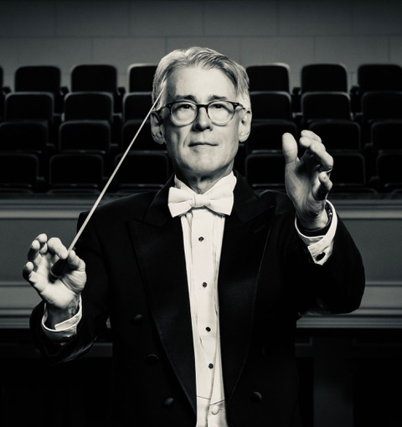
Bruce Knowles started his musical life in the Rapid City music program playing Double Bass in the Central High School Orchestra, Band and Jazz ensembles. After graduation Mr. Knowles earned a Bachelor of Arts degree in Music from South Dakota State University and a Master of Arts degree from Western Illinois University. His teachers have included: Edward Krolick, Leona Marek, Tanya Carey, Hratch Berberian, John Colson and Kenneth Singleton.

Mr. Knowles held the position Director of the Central High School Orchestras from 1982 to 2023. Under his leadership, they had a distinguished record of achievements: Superior ratings South Dakota Region Eight contests, Music Maestro Festival Gold Medalists, ASTA National Orchestra Competition 1st place Orchestra and overall Grand Champion, Chicago World Strides Music Competition 1st place orchestra, and overall Grand Champion. The Central High Orchestras have also been invited to perform at many regional and national conferences: the South Dakota Music Educators Conference, Nebraska String Educators Conference, the American String Teachers Association National Conference (2003 & 2008). In 2004 and 2012 the group was invited to perform at the Midwest Band and Orchestra Clinic in Chicago, Illinois.

Mr. Knowles has been active as a Double Bassist and Conductor. From 1982-2009 he served as Principal Double Bassist with the Black Hills Symphony and Black Hills Chamber Orchestra. He has been soloist with the Black Hills Chamber Music Society and the Black Hills Symphony. As a conductor, he has directed the Colorado All-State Orchestra, served as Associate Conductor of the Black Hills Symphony, and in 2009 was appointed as Music Director of the Black Hills Symphony.

