SOUTH DAKOTA MUSIC EDUCATION ASSOCIATION
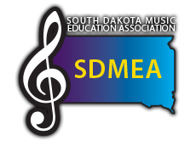
FOR IMMEDIATE RELEASE

{City, State} – South Dakota Music Education Association will present {Name of Event}, taking place at {Location of Event} on {Date}, and featuring {performers, guest conductors, showcases, etc.}.
SDMEA is proud to bring {Name of Event} to {Location of Event} for {the first time, the tenth year in a row, etc.}. {Name of Event} will {further description on what will take place at event}.
{More details about event; include ticket prices, if applicable, and where/how to purchase tickets}.
{Quote from performer, guest, previous attendees, critics, etc.}
The mission of the National Association for Music Education is to advance music education by promoting the understanding and making of music by all. SDMEA is a state affiliate of the National Association for Music Education. With over 400 members, SDMEA is the largest association of instructional musicians in the state catering to the needs of band, choral, general music and orchestral teachers.

